Checkers User Guide

Kieran Goldston - 34914400



Contents

Introduction 3

Hardware Specifications 3

Installation Guide 4

User Manual 7

The home screen. 7

The game screen. 8

Game rules 9

Troubleshooting Guide 10

If you are encountering errors 10

Potential problem 10

Potential fix or what to do 10

If you are having difficulty with program use 11

Back Page 12

# Introduction

Welcome to Checkers and thank you for using my program. This program is a simple checkers (also known as draughts) game coded in visual basic using visual studio 2019.

# Hardware Specifications

This program is very system un-intensive and should run on most modern computers.

|  |  |
| --- | --- |
|  | Minimum Requirements |
| OS  Architecture  Memory  Graphics | Windows 10  64-bit  1GB of Ram  Any basic graphics card |

# Installation Guide

Once the program is downloaded find and extract the .zip file. Any unzipping tool will work.

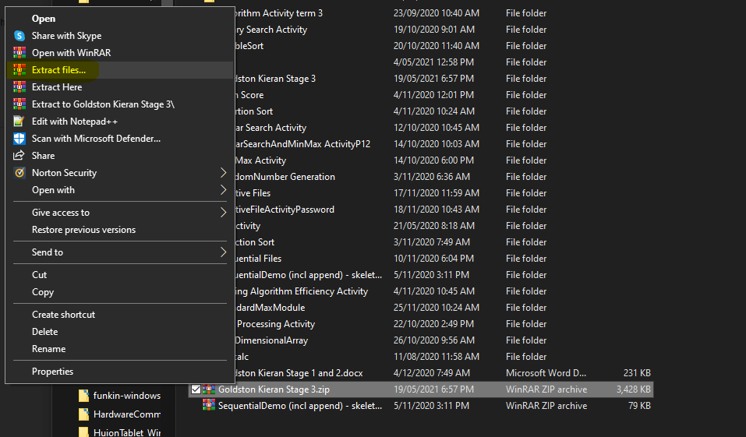

Once extracted open the file. Here you will find this guide in .docx form, the game folder, a tutorial, and a developer documentation folder. To Locate the game, click the folder named SDD Project y12.

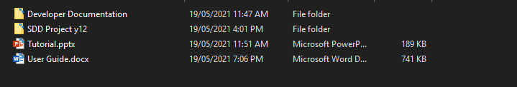

Next, locate the folder named bin and open.

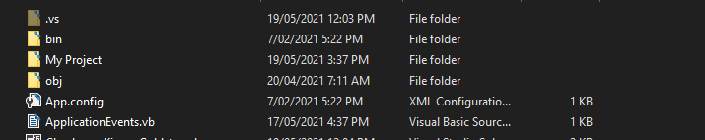

Then, open Debug



Here is where you will find the .exe file of the game, to start the program you will need to open this.

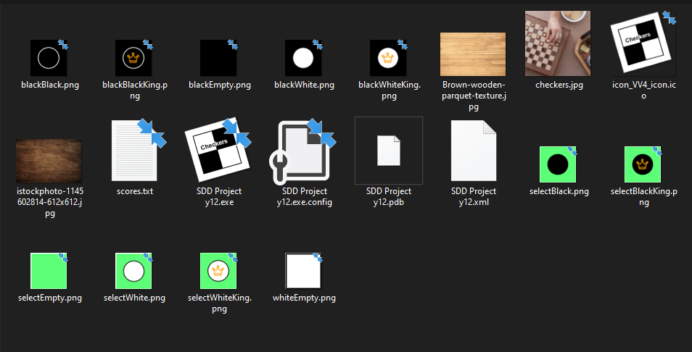

It is recommended that you make a shortcut of the .exe file and put it somewhere easier to access, you may also rename the file shortcut to anything you want.

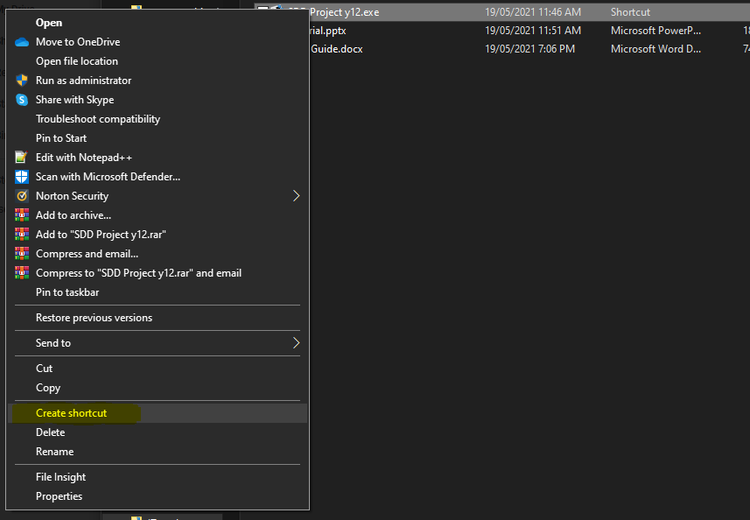

# User Manual

## The home screen.

Upon opening the program, you will be greeted by the home screen, as shown below.

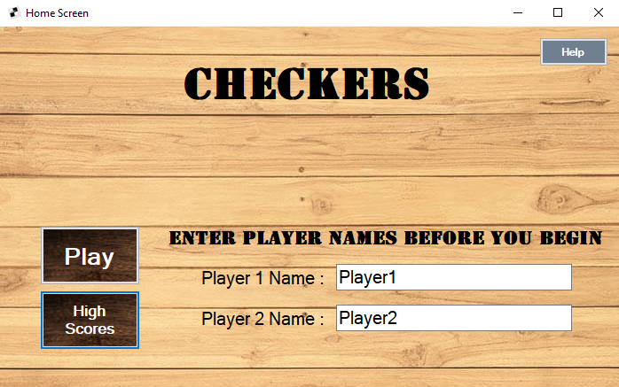

* If you are ever confused about how the game is played you can press the  button located in the top right corners of the home and game screens.
* The  button will take you to see the scores of previous players.
* To get started, enter both players’ names and click .

## The game screen.

After pressing the  button you will be greeted with the game screen, as shown below, to return to the home screen you can press the button .

**WARNING**, doing so will not save your current match although your scores are recorded after every match.

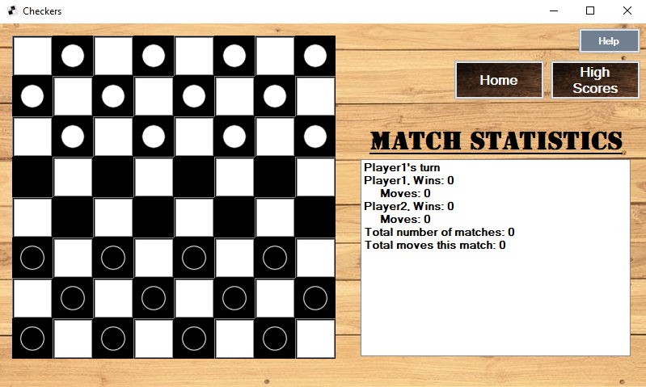

To start click on a piece and click on where you want to move the piece. The game will highlight the piece you have selected. If you ever want to cancel a move, just click on the piece a second time.

## Game rules

* White goes first.
* After a move is made the other player makes their move.
* Pieces can only move forward on the board unless it has reached the other side and has become a ‘King’ piece.
* To take a piece a player must jump over the other player’s piece.
* If a piece can be taken, then it must be taken.
* If a player takes a piece and lands in a position where they can take another piece, the turn will not change, and the player must take the next piece as well.
* A win is achieved when either one player has no pieces or cannot make a move. E.g., the final piece is trapped.
* Players will be scored based on how quickly (in moves) a win was achieved.

# Troubleshooting Guide

## If you are encountering errors

|  |  |
| --- | --- |
| Potential problem | Potential fix or what to do |
| Game crashes | If this occurs restart the program. Interrupted matches will not be able to be resumed. |
| Game fails to close properly | Open task manager and force quit the program manually. |
| Game freezes | If the game freezes at any point during use, it is recommended to close and restart the program. Interrupted matches will not be able to be resumed. |

If any errors are encountered, please contact the developer at [**Kieran.goldston@cgs.act.edu.au**](mailto:Kieran.goldston@cgs.act.edu.au) and notify me of the problem you are having so that I may reply with a potential fix and further improve upon the program in the future.

## If you are having difficulty with program use

Documentation about the game (including this user guide) can be found in the program’s main folder as shown below. If you are having difficulties you can refer to these for help operating the program.

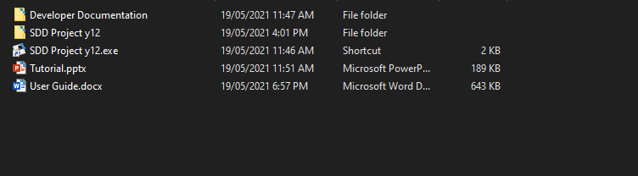

While running the program you can access an overview of the rules and more through the help window which can be opened through the  button located in the top right corners of the home screen and game screens.

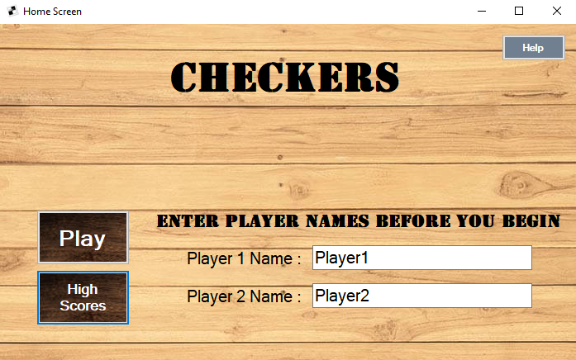

# Back Page